Presentation Preference: [1] Oral [2] Poster [3] either

Title in Arial (14 pt Bold) Using First Capital Letters

Fab Author¹, Sab Author², Cae Author^{1,2}.
(1) Institution, Full institutional address, email address of first author (presenting author).
(2) Institution, Full institutional address.

Keywords: Keyword1, Keyword2, Keyword3 (up to 5 keywords in Alphabetical order)

The presenting author should appear as the First Author. The total length of the abstract CANNOT EXCEED ONE PAGE. We recommend typing the abstract over this template in order to ensure that all abstract contributions have the same style in the final publication, i.e. text written in Arial 9 pt (justified) with page margins of 2.0 cm.

Abstracts can only be submitted through the online registration form and should be submitted as a .docx file. The file should be named as “Surname_CONFERENCE ACRONYM_Topic_TYPE OF PRESENTATION.docx”, corresponding to the presenting author, the conference acronym (EuSP or GSAC), the topic number and the type of presentation (Poster or Oral). Examples are: Smith_TTW6_POSTER.docx or Smith_TTW6_ORAL.docx. Each presenting author can submit up to two abstracts.

When submitting your abstract, please, choose the most relevant topic number. The organizing committee reserves the right to decide on a final topic assignment upon abstract evaluation.

If the authors wish to include a Figure, they should leave one line before and after it. The corresponding captions (Arial 8 pt) should straight follow the Figures, without any line between the Figure and its caption. Figures should be legible when printed in Black & White.

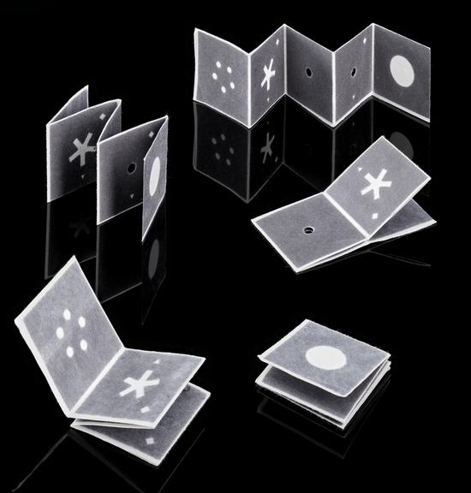

The sections for acknowledgements and references, if any, should appear at the end (Arial 9 pt). Leave one line before the section titles. References should be sequentially numbered in the text and indicated in square brackets (e.g., “… [1,2]”). Please follow the corresponding styles for articles in journals [1], books [2] and chapters in edited books [3].

Acknowledgements
Thank you for reading these instructions. For more information please feel free to contact us by email.

References
[1] J. van der Geer, J.A.J. Hanraads, R.A. Lupton, The art of writing a scientific article, J. Sci. Commun. 163 (2010) 51-59.
[2] W. Strunk Jr., E.B. White, The Elements of Style, fourth ed., Longman, New York, 2000.
[3] G.R. Mettam, L.B. Adams, How to prepare an electronic version of your article, in: B.S. Jones, R.Z. Smith (Eds.), Introduction to the Electronic Age, E-Publishing Inc., New York, 2009, pp. 281-304.

Biography

For keynote and invited speakers, please provide a short biography within 100 words below.

